Question 1
Q. What is conditional rendering in React? How can you conditionally renderelements in a React component?
Ans : Definition:
- Conditional Rendering In React Means Displaying Different UI Elements Based On Certain Conditions Or State Values.
- It Works The Same Way As Conditions In JavaScript But Inside JSX.
Ways To Conditionally Render Elements:
- Using if-else Statements.
- Using The Ternary Operator (condition ? truePart : falsePart).
- Using Logical AND (condition && element).
- Returning null To Render Nothing.

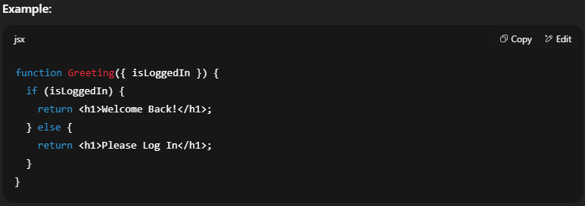

Question 2
Q. : Explain how if-else, ternary operators, and &&(logical AND) are used in JSX for conditional rendering.
Ans : 1. if-else Statement:
- Used Outside JSX Or Inside Functions To Decide Which Component To Return.
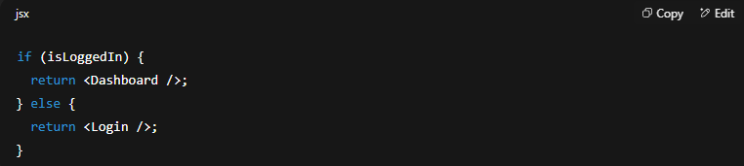
2. Ternary Operator:
- Shorter Syntax, Can Be Used Directly Inside JSX.
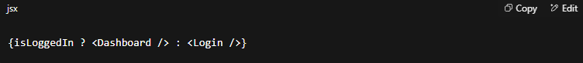
3. Logical AND (&&):
- Renders The Right Side Only If The Left Side Condition Is true.

Note:
- if-else Is Best For Multiple Conditions.
- Ternary Operator Is Best For Two Possible UI Outcomes.
- Logical AND Is Best For Showing Something Only When A Condition Is True.

